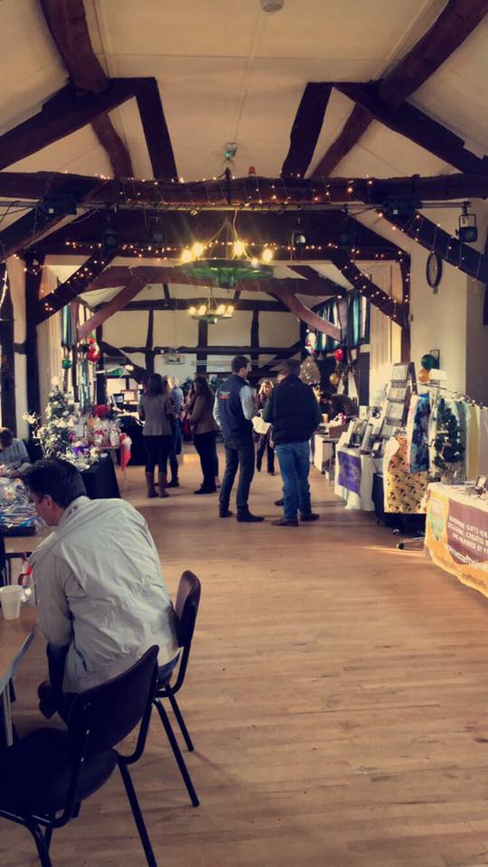
Bromsgrove YFC Charity Craft Fair and Coffee Morning

On 17th December 2016 Bromsgrove YFC held a charity craft fair and coffee morning at Belbroughton Village Hall. There was a lovely atmosphere in the hall with many stall holders agreeing they had all enjoyed themselves and made some cash too!
The footfall was great, up on last year’s numbers and the number of YFC members attending and helping out was brilliant, with members from neighbouring Cutnall Green and members all the way from Upton on Severn YFC popping along for support- thanks to you all.
Cakes and Coffees were sold in abundance and we raised £378.00 for our chosen charities for this event. The day went smoothly and we enjoyed hosting the event. Keep up the good work BYFC. The next craft fair and coffee morning will be 16th December 2017. See you there!

