WORCESTERSHIRE FEDERATION OF YOUNG FARMERS’ CLUBS

Dodge Ball – (10-16 yrs old) COMPETITION 2017-18

VENUE: The De Monfort School, Four Pools Road, Evesham, WR11 1DQ

DATE: Sunday, 5th November 2017

POINTS: Awarded will count towards the Sports Shield only.

ENTRY FEE: £25

ENTRY FORMS: Completed entry forms together with the correct Entry Fee must be returned to County Office by Monday 2nd October 2017

ELIGIBILITY: A squad of Eight (8) players, from whom Six (6) players will be chosen to form a team for each game, which must include a minimum of three (3) girls. All players must be aged 10 years and over and 16 and under on 1st September 2017 (this age range must be adhered to), and full members of a Club affiliated to WFYFC may be nominated. This means competitors must have attained their 10th birthday on 1st September 2017 but may be 17 on the day of the competition.

PROCEDURE: Please see attached WFYFC rules

OUTCOMES: Dodgeball skills, teamwork, adhering to rules, exercise, fun, winning/losing, personal development skills and improving own performance
----------------------------------------------------------------------------------------------------------------------
Entry Form from _____________________________YFC for the Dodge Ball (10-16 yr olds) Competition 2017-18

Entry Fee: £25

Name | Membership Number

Signed _______________________________________(Club Officer)

This entry form to be completed and returned to County Office by Monday, 2nd October 2017

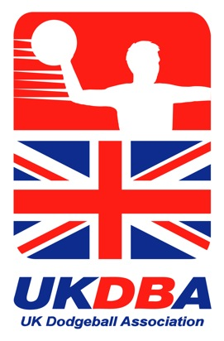
NATIONAL FEDERATION OF YOUNG FARMERS’ CLUBS
Status FINAL
08.07.2017
Eliminator

Competitions Programme 2017-18

NFYFC DODGEBALL - MIXED

(10-16 years old)
Sponsored by UK Dodgeball
RULES
Competition Aim
To provide members with the opportunity to take part in a National Dodgeball Competition.

Learning outcomes
Dodgeball skills, teamwork, adhering to rules, exercise, fun, winning/losing, personal development skills and improving own performance

REMINDER: Read in conjunction with NFYFC General Rules. Further information can be found at http://www.nfyfc.org.uk/CompetitionsResources/competitionsresources
- DATE & VENUE
  - After Area Eliminators, the National Final will be held at the Sports Championships – Sunday 1st July 2018 in Staffordshire.

- REPRESENTATION
  - Counties may enter one team per 600 members or part thereof in Area Eliminators.

  - Areas will be represented in the final by one team per 3,000 members or part thereof. (Northern Area 2, Eastern Area 1 and East Midlands 1, West Midlands Area 1, South West Area 2, South East Area 1 and Wales 2)

- ELIGIBILITY
  - A squad of Eight (8) players, from whom Six (6) players will be chosen to form a team for each game, which must include a minimum of three (3) girls. All players must be aged 10 years and over and 16 and under on 1st September 2017 (this age range must be adhered to), and full members of a Club affiliated to NFYFC may be nominated. This means competitors must have attained their 10th birthday on 1st September 2017 but may be 17 on the day of the competition.

- SUBSTITUTION
  - If 4 or more than the original squad members are unable to go forward to subsequent rounds, then the next highest placed team from the previous round will represent the Area.
  - All substitutes must have been eligible to compete in the County Final.

- PROCEDURE (Recommended Playing and Administration Rules as laid down by the UK Dodgeball Association)
  - The matches will be played either in 2 leagues with the winner of each league playing for 1st and 2nd place, or as a round robin tournament depending on the number of teams taking part and number of pitches available on the day of the National Final.

  - League points will be awarded as follows:
Win 3
Score Draw 2
No Score Draw 1
Lose NIL

  - Each team has 6 players on the court at the start of a game.

  - Each game lasts for 3 minutes and the match will be the best of 3.

  - 3 balls are placed in the Dead Zone at the start of a game.

  - Once the start of the game is signalled by the referee, 3 players from each team run to gain possession of the balls. Balls must be taken or passed to the back of the court before the first attempts are made.
  - The LEADING team, in the game (the team with the most players on the court), has 5 seconds to throw balls at their opponents, when it has possession of more than 2 balls. Throws must be valid attempts. Leading teams can retain possession of 1 ball.

  - When you catch a throw from an opposing player, they are out and one of your players comes back in. Players are allowed to fumble a ball while catching; but they must retain possession at the end of the catching action, while remaining on the pitch and without the ball touching any other player or any other ball, object or surface.

  - Catches bring players who are out back into the game in rotation (First out – first in).

  - You can use a ball in your possession to block a thrown ball, but you are out if the ball is knocked from your hands when you try to block the incoming ball.

  - You win a game by putting out all the opposing team, or by having more players left on court at the end of the 3 minute game.

  - Substitutions are allowed between the 3 minute games

  - Head shots count – DELIBERATE head shots DO NOT COUNT and the thrower is OUT.

  - No taunting opponents is allowed

  - YOU ARE OUT:
    - When a ball hits you directly, which is thrown by an opponent (clothing counts as part of the player’s body)
    - When an opposing player catches your throw
    - When you step into the Dead Zone (hands/arms are allowed)
    - When you touch a boundary line or the floor, wall, barrier over the boundary line or on the opponents side of the court
    - When the Referee calls you out for any reason. The referees decision is final and no arguing with the officials is allowed and you can be ejected from the match.
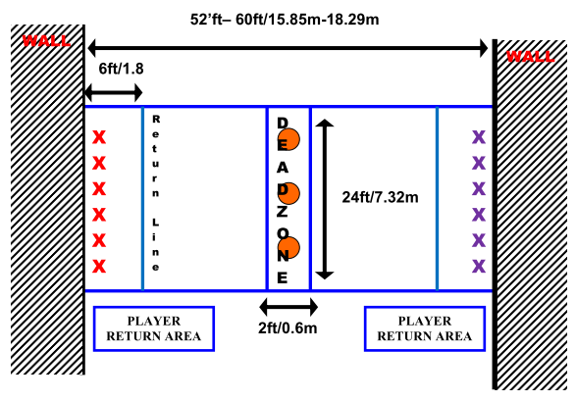

- AWARDS
  - Trophy and NFYFC Prize Cards to the winning team.
  - NFYFC Prize Cards to teams placed 2nd, 3rd and 4th.
  - NFYFC Certificate of Achievement will be awarded to all members of teams in the National Final.

- NOTES
  - It is advised to have either St John Ambulance or The British Red Cross with an ambulance in attendance at both County and Area Rounds.
  - It is advised that qualified referees are used in order to minimise any risk to members but competent persons with a good knowledge of Dodgeball Rules may be used.
  - Further information and explanation can be found at www.ukdba.org

