**Membership No:** office use only

**National Federation of Young Farmers’ Clubs Membership Form 2020/21**

*If completing by hand please complete in blue/black ink in block capitals*

**Section 1 – Essential Information**

**Title:** **First Name:**  **Surname:**

**Preferred Name:**

**Date of Birth:** **Age:**

**I identify my gender as:**

Male : Female: Self Identify:

Please use this space if you wish to self identify

**Address:**

**Postcode:**

**Home Tel no:**  **Member’s mobile no:**

**Member’s email address:**

**Club:**

*(U18 members only)*

**Parents name: Parent’s email address:**

**Section 2 – Health & Wellbeing Information**

To ensure you/your child is able to participate and enjoy the activities and opportunities that YFC provides we ask that you complete the following health information and details of dietary requirements, medical conditions, disabilities or special educational needs (SEN)

**Do you have any of the following?**

Please provide additional information

Health conditions **Yes/No**

Disability **Yes/No**

SEN **Yes/No**

Allergies **Yes/No**

Other additional needs **Yes/No**

Dietary requirements **Yes/No**

**Any other relevant information we need to be aware of (e.g. Medication):**

Please provide additional information

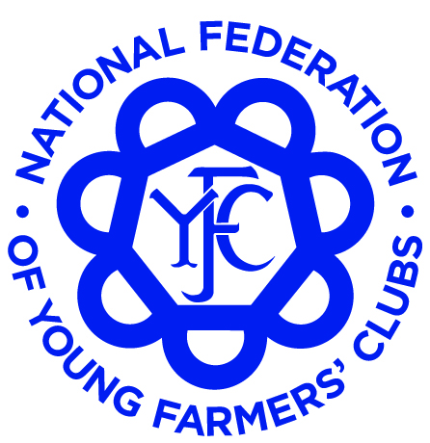

[www.nfyfc.org.uk](http://www.nfyfc.org.uk)

**Find Us**

[\\Sbs\company\ICT\icons\socialmediaicons_v190\facebook-16x16.png](https://en-gb.facebook.com/nfyfc/) [\\Sbs\company\ICT\icons\socialmediaicons_v190\twitter-16x16.png](https://twitter.com/NFYFC) [](https://www.instagram.com/nfyfc)

**Section 3 – Emergency Contact Details**

**Emergency Contact Details (ICE)** (2 for U18 year olds and at least one for over 18 year olds)

**Name:**  **Relationship:**

**Main contact number: Alternative phone number:**

**Name: Relationship:**

**Main contact number: Alternative phone number:**

**Section 4 - Marketing Preferences**

As part of your membership of NFYFC, we will keep you informed of relevant membership news, events and activities through our communication channels both online and in print. These include NFYFC membership magazines **(if produced)** and e-newsletters sent to your email address. Otherwise, NFYFC and your county federation will only use your email to contact you from time to time about opportunities that may be available to you as part of your membership or in relation to your role within YFC. Your details will not be shared with 3rd parties for marketing purposes.

**So we can ensure you receive these membership publications, can you confirm you are happy for us to send these to you.**

Would you like to receive NFYFC membership magazines to your home address?   **Yes/ No**

Would you like to receive the e-newsletters via email?                                                         **Yes/ No**

Do you wish to receive membership magazines in?  English:                     Welsh:

**Member Signature: Date:**

**Parent/Guardian Signature: Date:**

Office use only:

Member Paid

**Privacy notice**

For more information on our privacy notice visit the National Federation of Young Farmers’ Clubs

Website at: [http:\\www.nfyfc.org.uk\privacy](http://www.nfyfc.org.uk/privacy)