Success at YFC Stock Man of the Year competition 2017

Bromsgrove YFC has had a brilliant start to the 2017 year winning overall stockman of the year team 2017 at the competition which took place on 22nd January 2017. Despite the freezing temperature and early morning the club were able to enter two senior teams. Team A consisted of James May, Hannah Owens, Max Wood and James Wood and Team B had Chris May, Jonny Pearman, Lyndsey Jones and Oliver Raybould.
Team A won 1st prize overall with Team B just missing out on 3rd prize with a very respectable 4th placing. Individually, Bromsgrove were also fantastic with James May winning overall stockman of the year gaining a lovely shield and Hannah Owens gaining 2nd prize stockman of the year!
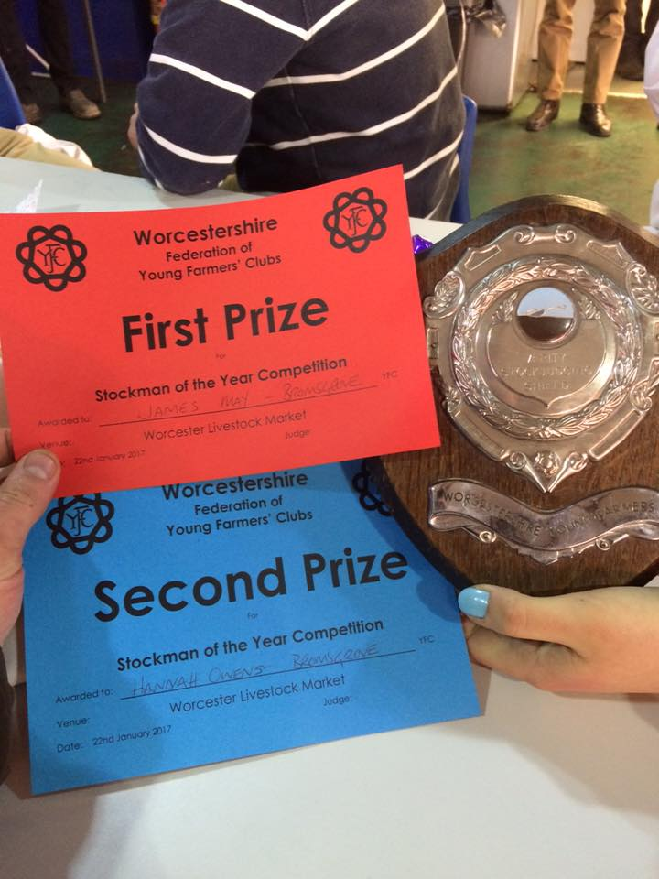
Well done guys and keep up the excellent work!

