Young Stock Judger Of The Year
- A team consists of 4 people
- Each team will judge 4 different rings of stock
- Each person is required to dress smartly and wear a white coat
- Each team member will complete a short multiple choice questionnaire on animal husbandry and health( see examples of questionnaire)
- The stock will be 4 out of the 5 things listed here: 4 Dairy Cows
4 Butchers Lambs
4 Commercial Breeding Ewes
4 Butchers Pigs
4 Beef Cattle
- Each member of the team will judge all 4 different rings of stock and try and place them in order of best to worst.
- The stock will be labelled A,X,B and Y
- Each member will be given 10 minutes to judge each ring of stock and 5 minutes for preparing prompt cards.
- Members are then asked to explain their reasoning for why they placed the stock in the order they did. They will have 2 minutes to do this. There are time penalties if members go over the 2minutes. 2 marks will be deducted for each 15 seconds of time over.
- There will be prizes for the combined marks of the team and also individually
Breakdown of Marks
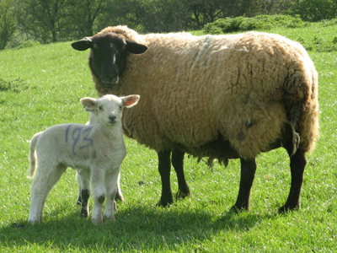
Placing of the stock x4(50 per ring) = 200
Reasons given x4(50 per animal)= 200
Questionnaire= 100
TOTAL MARKS= 500
When giving your reasons
- Establish how long you have, usually two minutes are allowed.
- Memorise your reasons, as much as possible.
- Picturing the animals will help.
- Stand up straight and look the judge in the eye.
- Speak clearly and slowly enough for the judge to follow.
- Greet the judges ( Good morning/afternoon Mr/Madam Judge)
- Describe the stock fully, refer to any distinguishing features
(eg white face).
As you deliver your reasons compare as much as possible, going from front to back or back to front using the same style for all animals in the class with emphasis on the important areas. This means that you are less likely to get confused and allows the judge to follow your reasons more easily.
- Use the full time allocated, the clearer your reasons, the better your chances.
- Thank the judge when you have finished – whether you enjoyed the experience or not. Judges rarely remember if you thank them, they always remember if you don’t!

